Practical 1: logic gates

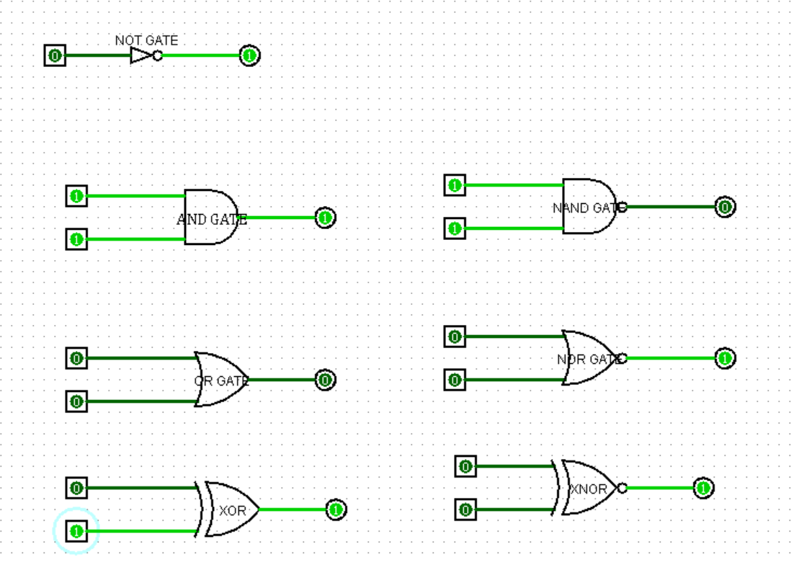

Practical 2: Boolean expression

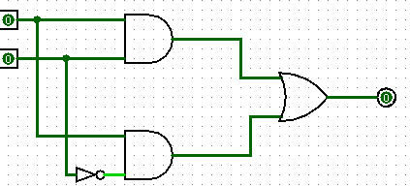

Practical 3:

Half adder

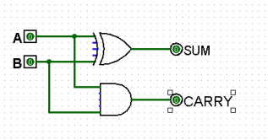

Full adder

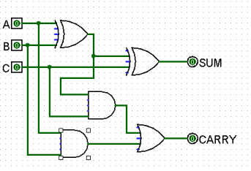

Practical 4:

Half subtractor

Full subtractor

Practical 5:

4-bit magnitude

1 -bit magnitude

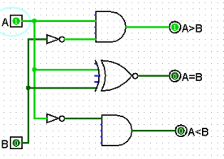

Practical 6: flip flop

SR

D flip flop

JK

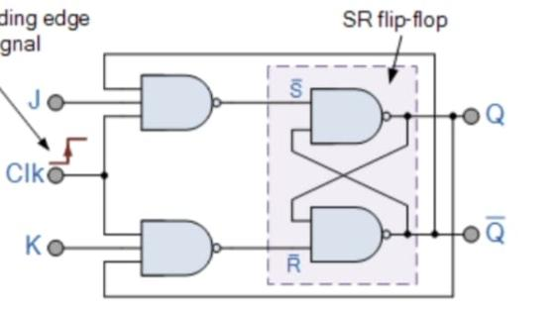

Practical 7: synchronous and asynchronous

Synchronous

Asynchronous

Practical 8:shift register

Practical 9:

Multiplexer

Demultiplex

